**Setting up the Xerox WorkCentre 3335 for Wi-Fi printing**

Before Reading this Guide, please set up the printer and get to the “Home” Screen.

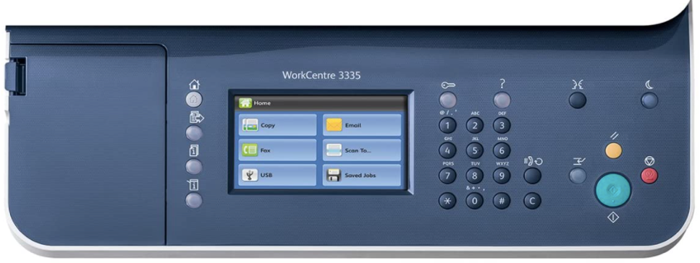

The home screen should look something like the above image

1. Once the Printer is set up and is on the Home screen, please press the “Key”  button to log in and configure the wireless setup.

***The printer will prompt you for a user name. The default user name is “admin” (without the quotations)***

***Once you type “admin”, press the button with the arrow pointing right in the top right corner of the screen.***

***The printer will prompt you for a password. This password is the serial number of the printer and is unique to each printer. To find the serial number, turn the printer and view the rear of the printer.***

***You will see a label in the center that will list the serial number.***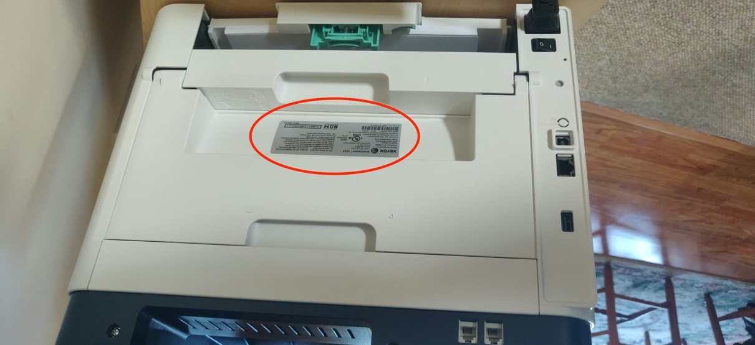

***This is where the Serial Number is located. For this printer, then, the password would be 5BT172272.***

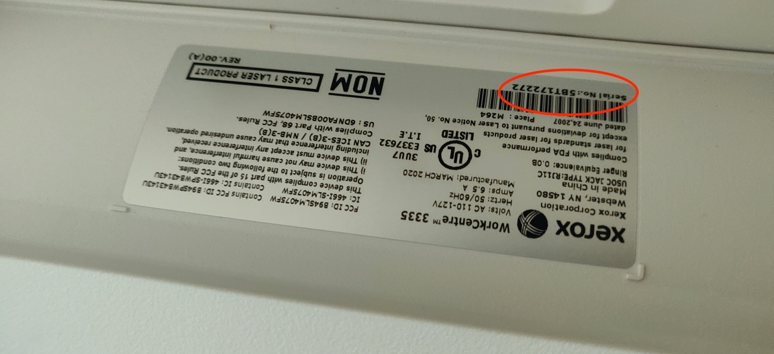

***Once you have located your password/serial number, enter that into the printer.***

***The printer will then ask you to change the password as the default password is weak.***

***You may change this to whatever you wish, but please TAKE NOTE of the password, as it will be needed at a later time.***

2. Once you have changed the password and are logged into the printer, press the *Machine Status* button.  It is the left bottom button on the front of the printer.

The following me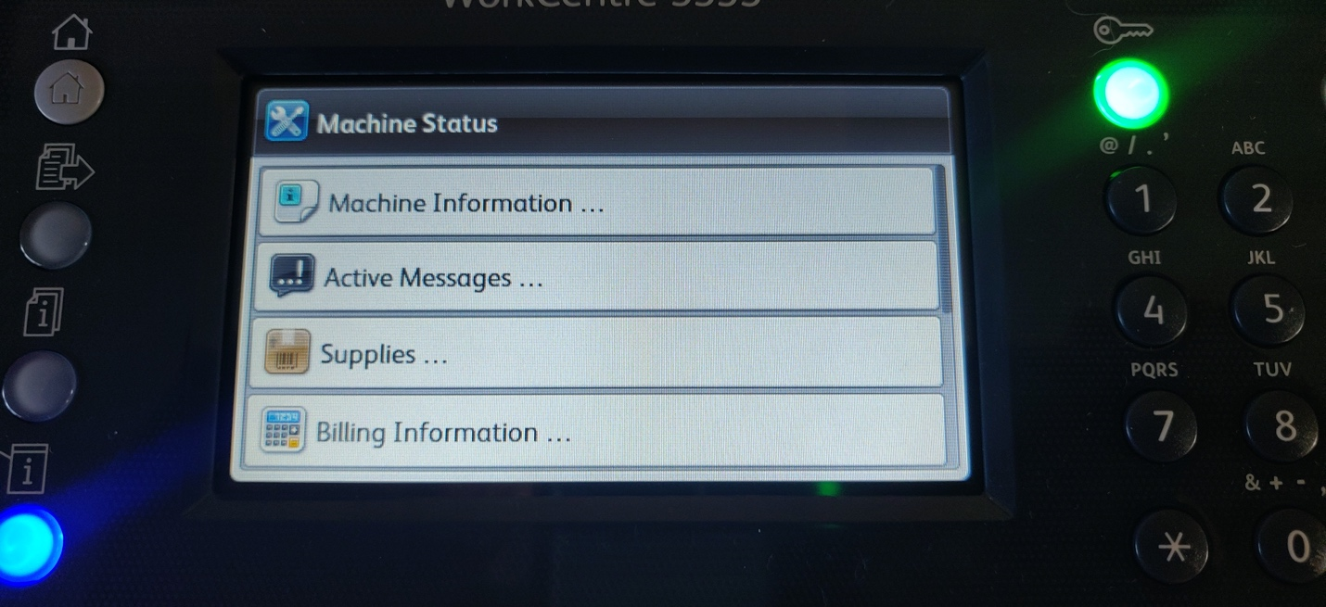nu should appear

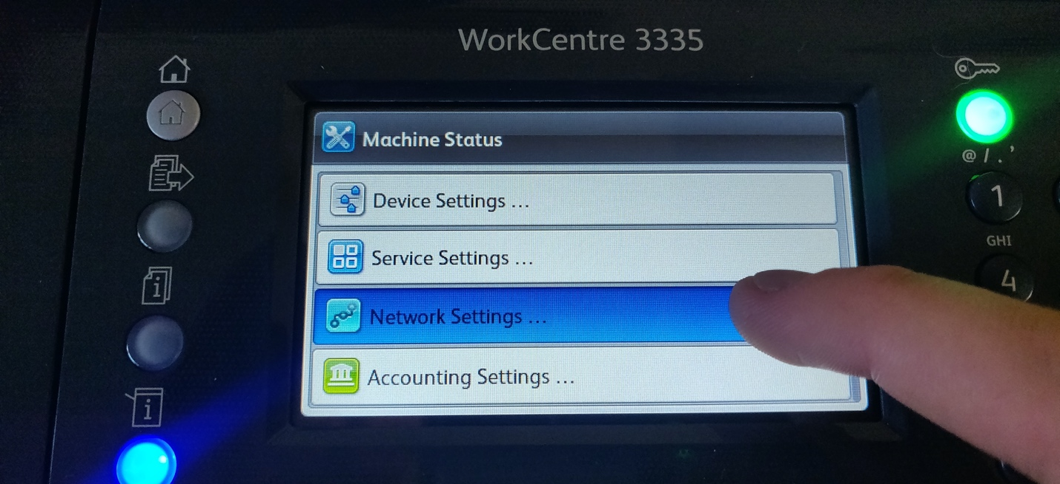3. Once on this menu, use your finger to scroll down and select network settings.

Then, select Network Connectivity

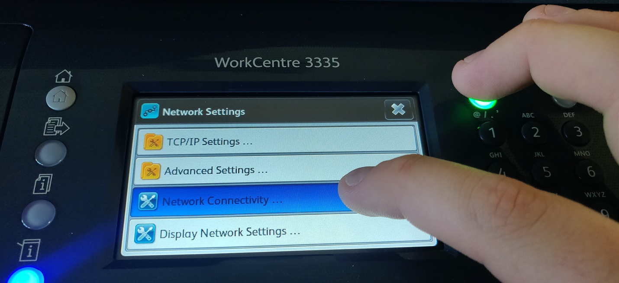

4. You should get a screen that looks like this. Select the drop down arrow and select Wireless as shown in the image below

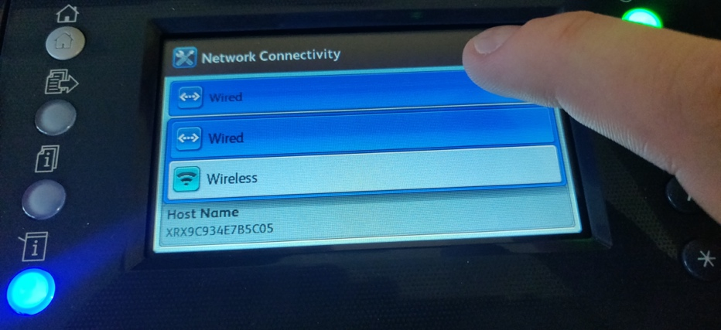

Once selecting *Wireless*, the printer should search for Wi-Fi Networks.

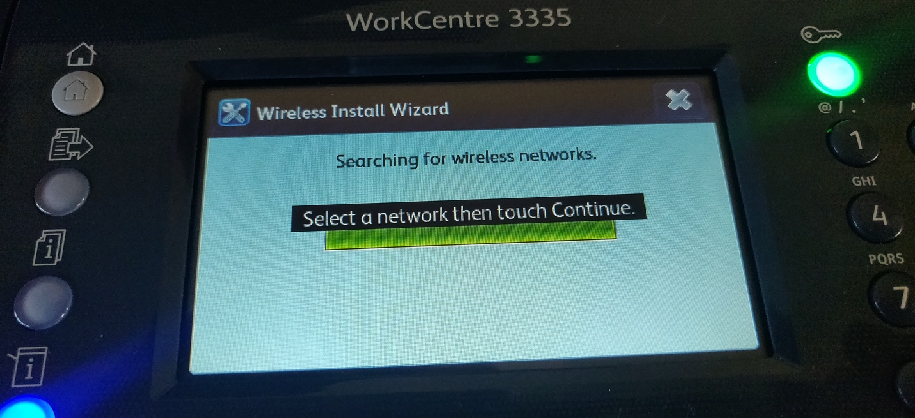

5. The list of networks should appear. Choose your own personal network. This should be the same wireless network that your Work computer is connected to.

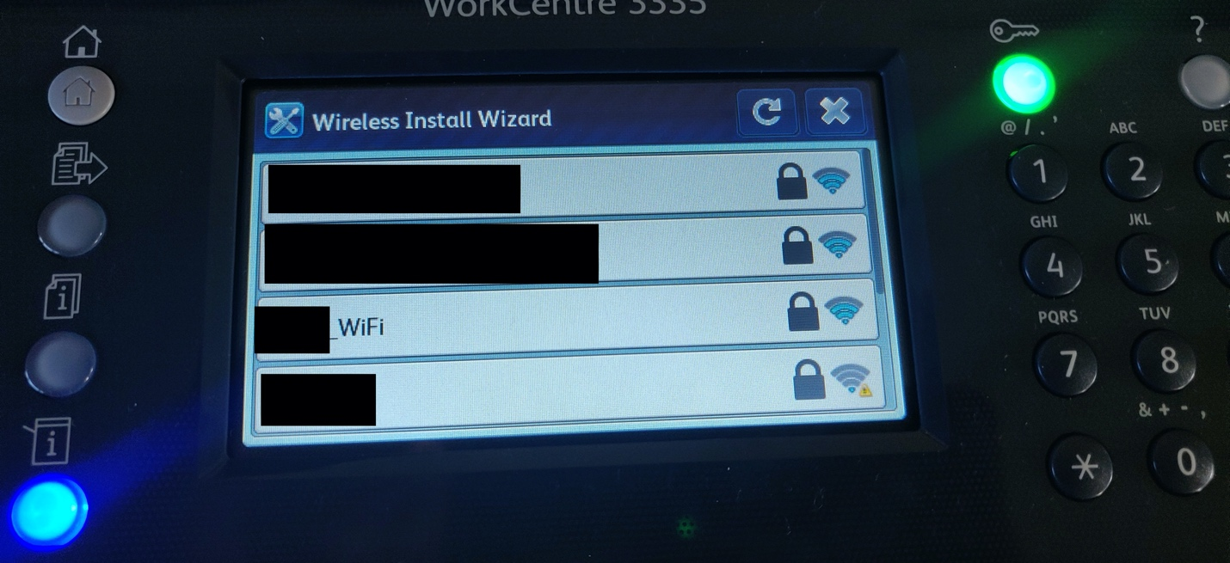

6. Once you choose your personal network, the following screen will appear. Choose the *Network Login…* button.

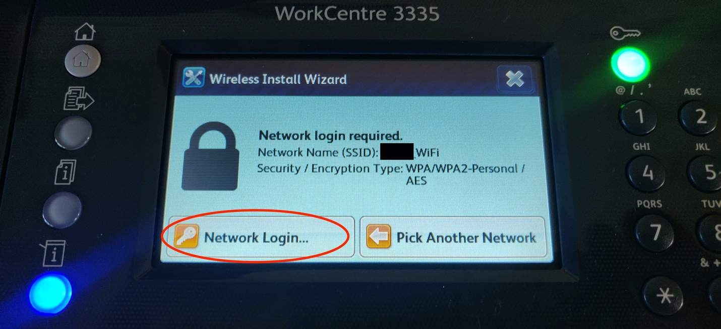

7. You will then be prompted to enter your Wi-Fi password. Enter it and then press the check mark button.

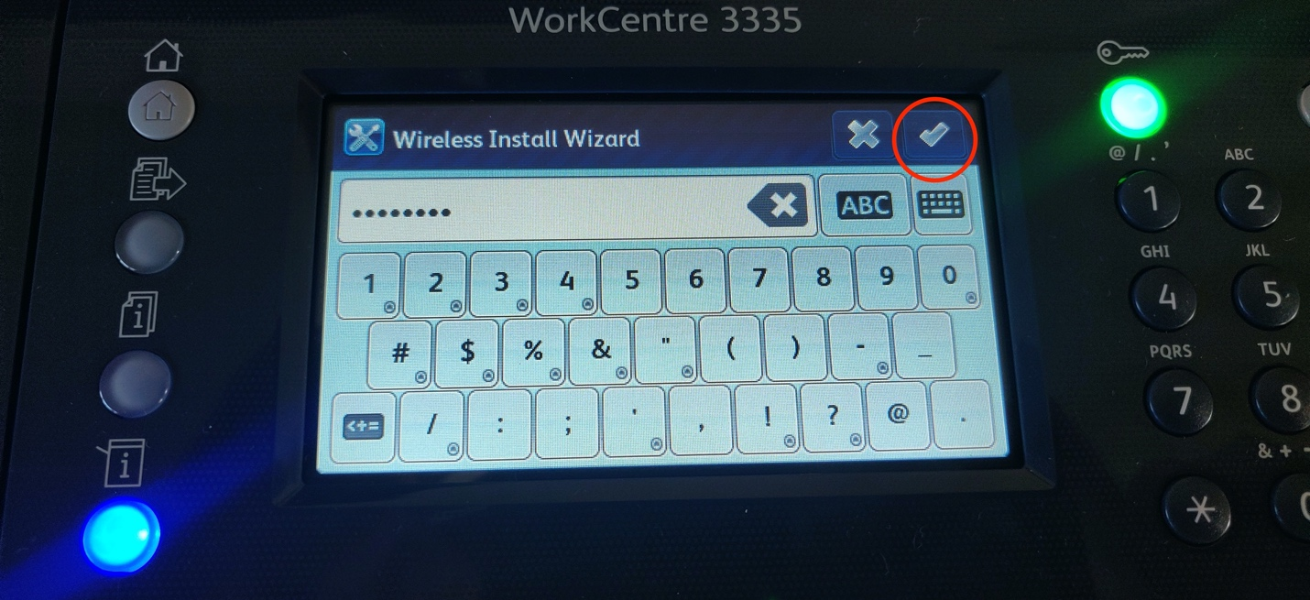

The printer will then attempt to connect to the network.

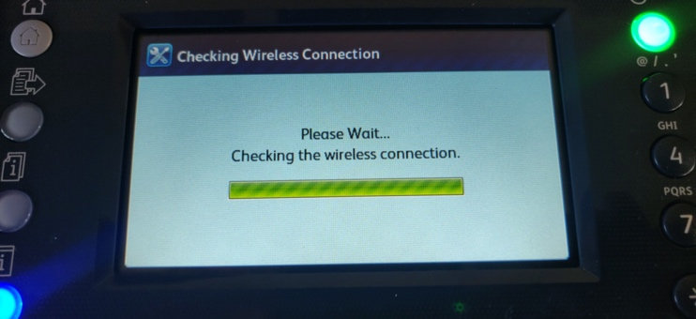

8. If the password was entered correctly, the printer should now display a screen similar to the one shown below.

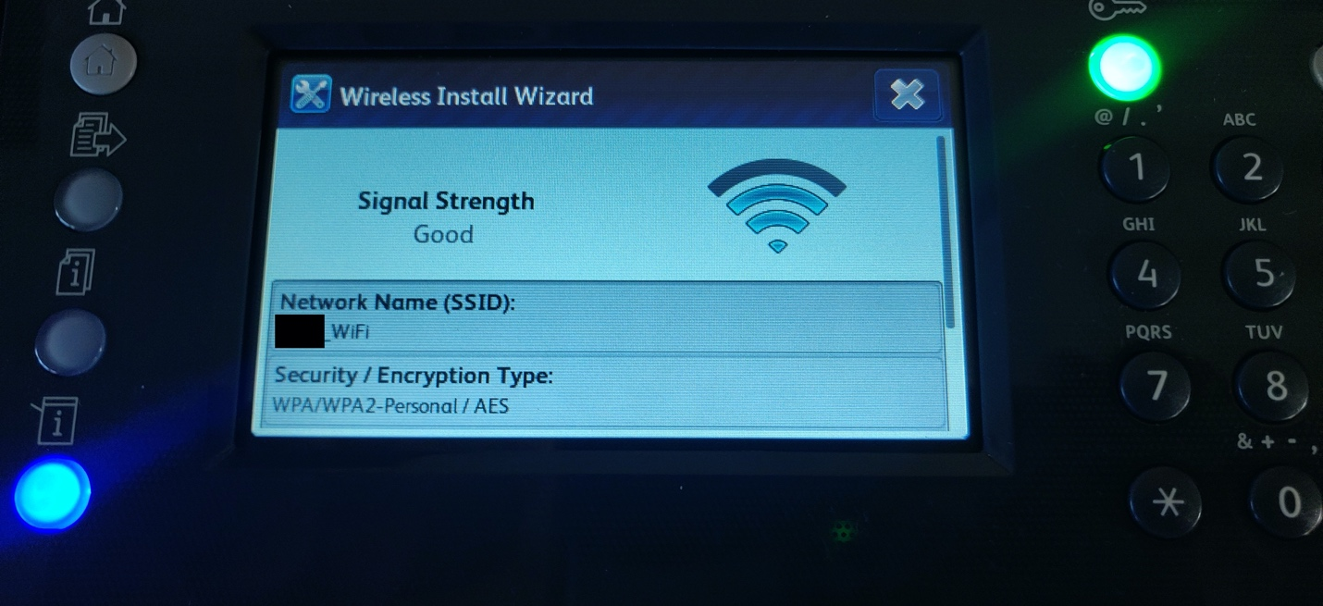

9. If you see the screen above, you have successfully set up the printer on your Wi-Fi network!

Now we are done configuring the printer, so we can log out of it now.

10. Press the Green *Key*  button.

The following screen should appear

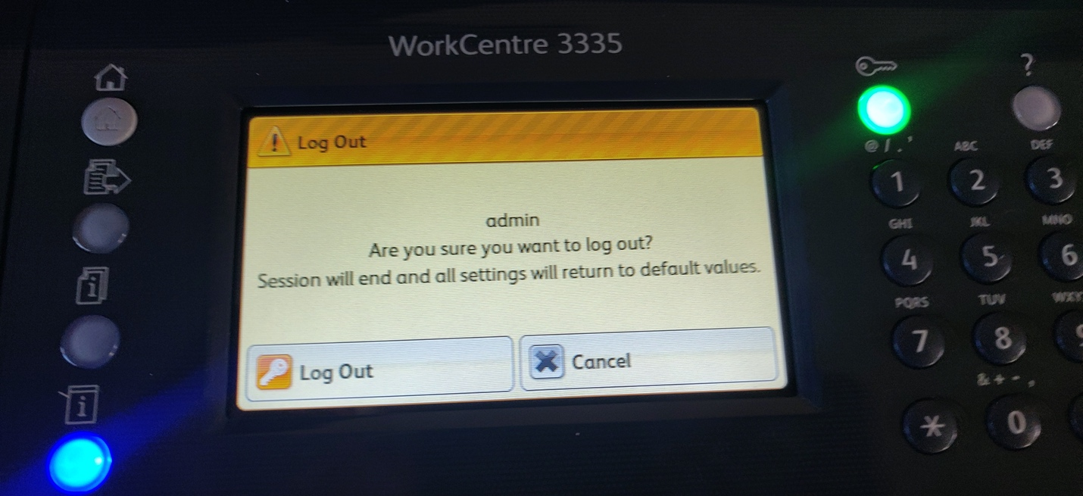

11. Press the *Log Out* button.

Now that we are done with the printer, go to your computer and set up the printer using the following instructions.

12. Log into your computer per usual. **Be sure to check and make sure that your computer is connected to the same Wi-Fi network as the printer!**

13. While at your desktop, press and hold the Windows key Enable or Disable Windows Key in Windows 10 | Tutorials and press the R key on your keyboard at the same time.

The *Run* dialog box should appear. Type “control printers” (without the quotes).

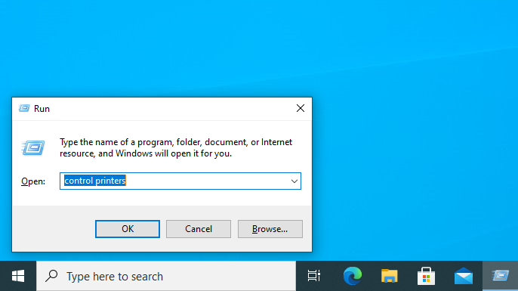

14. A window similar to the one shown below should appear. Click *Add a Printer*.

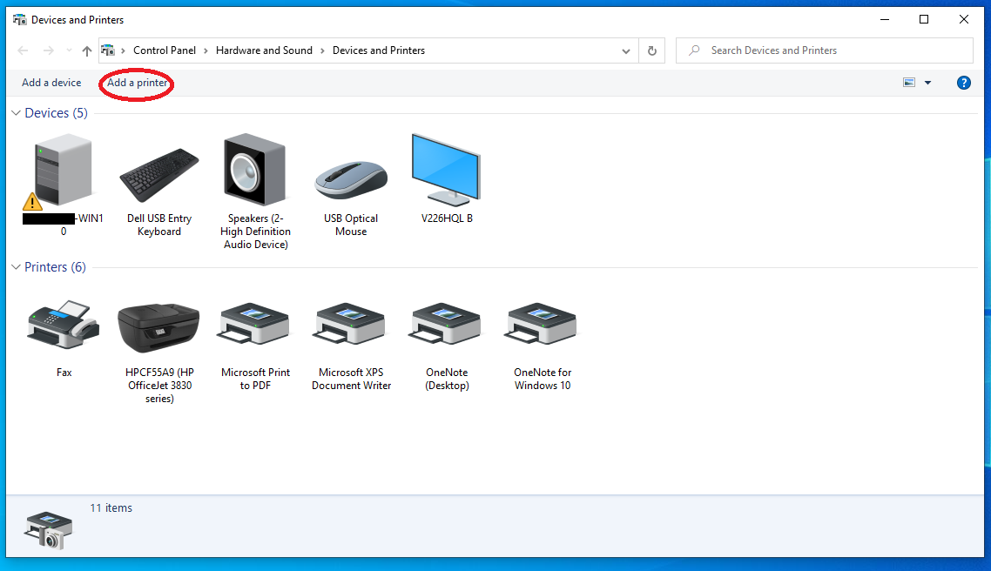

15. Another window should appear and your computer will search for printers on your Wi-Fi network. You should see a printer starting with XRX9….. listed. This is the printer you want to select. Click on that printer and then click *Next*.

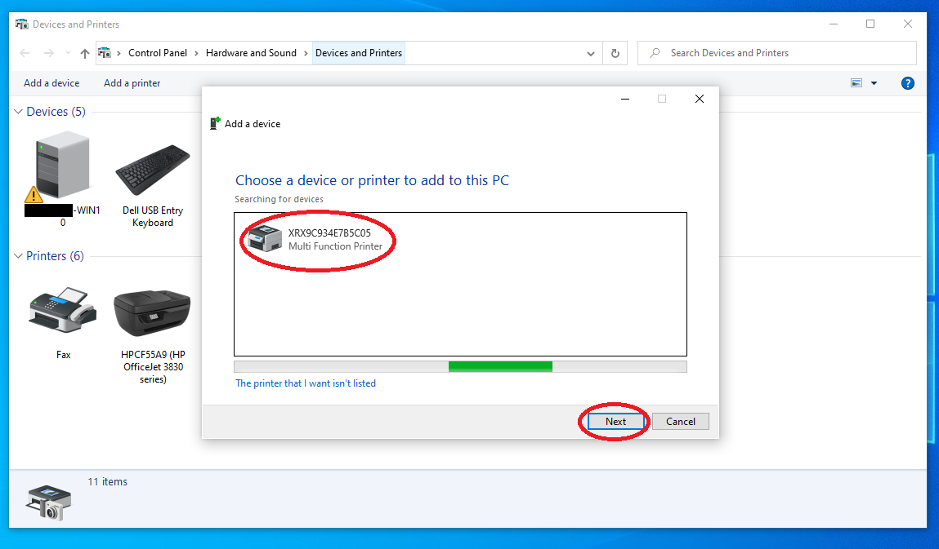

Your computer will then attempt to connect and set up the Xerox printer.

This can take a minute.

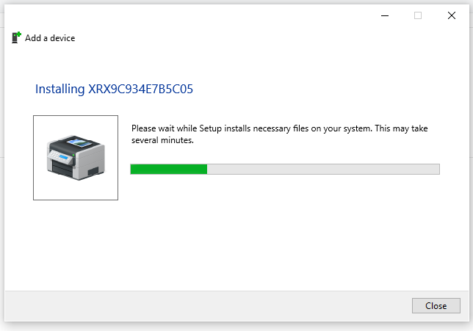

16. After a minute or so, you should be presented with the following screen. Please click *Print a test page*. This will print a test page to make sure that the printer is working and that the computer can communicate with it.

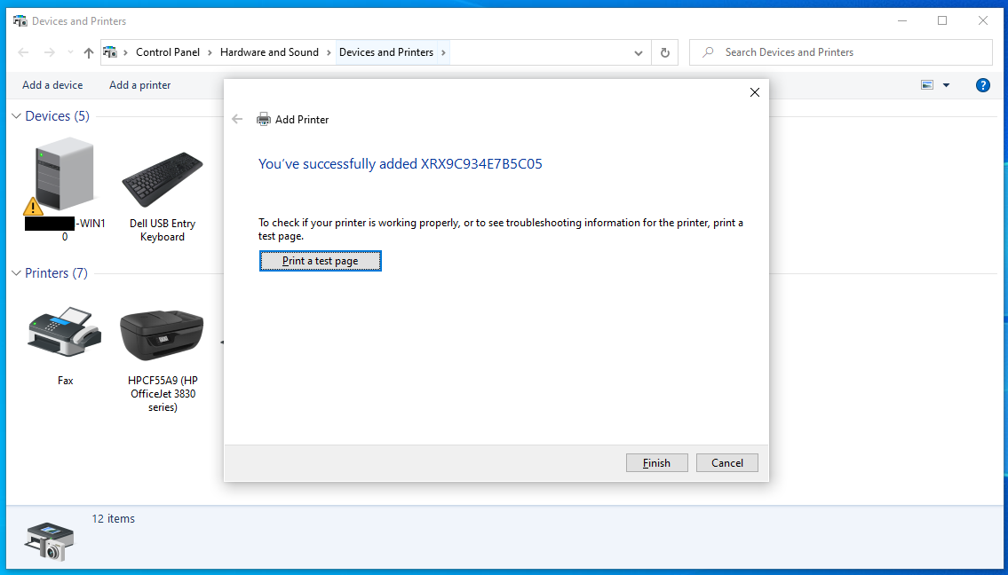

17. Click *Finish*.

18. The printer should now be in the list of printers. Right click on it and select *Set as default printer*. Then click *OK.* This will make this printer show up as the first option in the list of printers when attempting to print using the Microsoft Office suite. *(Word, Excel, PowerPoint, etc.)*

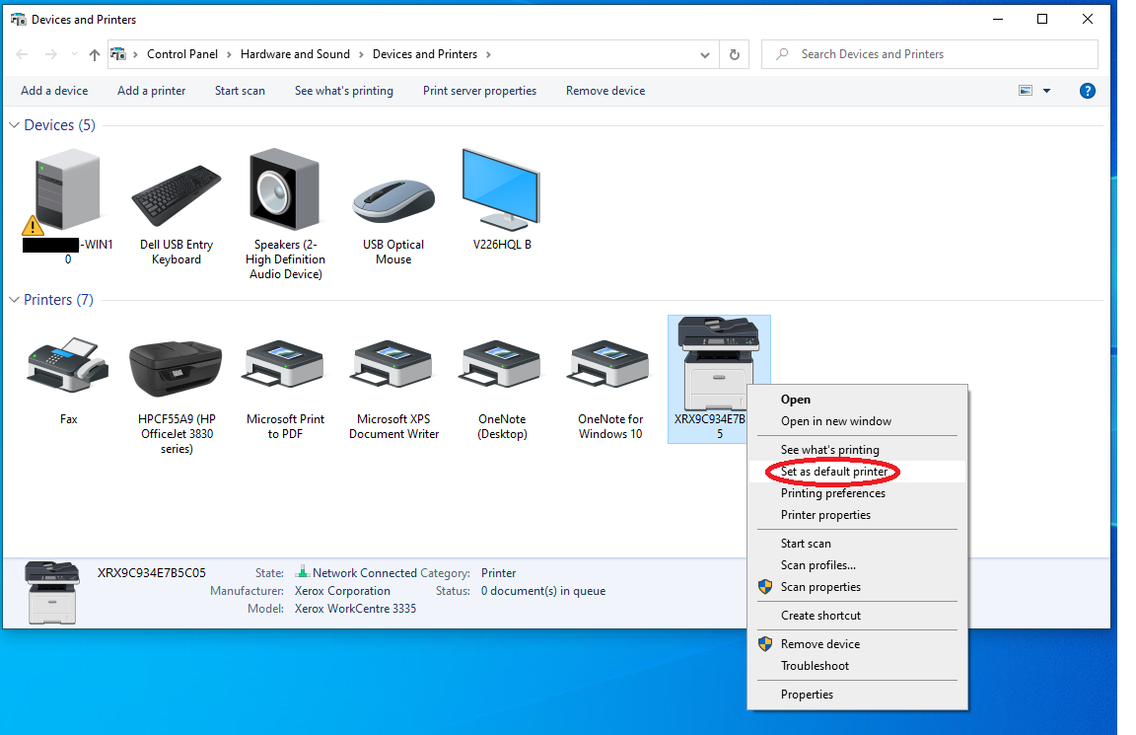

19. You may now close the Devices and Printers window.

**Your printer should now be set up and ready to print over Wi-Fi!**